Name: Mai Ngoc Diem My
Course: Web authoring
CTS1831C Homework 6 JavaScript 1
1. Let us start by re-creating the ‘Hello World’ JavaScript example that you have seen in the lectures.
Is the code correct now or does it produce an error? What does that tell you about the scope of a variable declaration?
- When declare a variable in a script, that variable is global so the statements in the others script can get the value from that variable. However, because the code run top down so when we declare the variable in the script with id s3, the statement from script with id s2 cannot get the value because the variable did not executed. On the other hand, when we move the variable to script with id s1, the statement below it can get the value from the variable.
We need to consider one more possible way in which the scope of variable declarations might work. In a lot of programming languages, the scope of a variable is restricted to the block in which it is declared. For example, a variable declared in the then-branch of a conditional statement has the then-branch as its scope. On the else-branch of the same conditional statement (or anywhere else), the variable would be undeclared. Let us see whether this is the case for JavaScript. Add the following code before the noscript-element in jsDemo06A.html:
<!--Exercise 1-->
<script id="s4">
if(false) {
var x = 519;
} else {
document.writeln("The value of x is " + x + "<br>")
}
</script>
What output or errors does the script produce now?

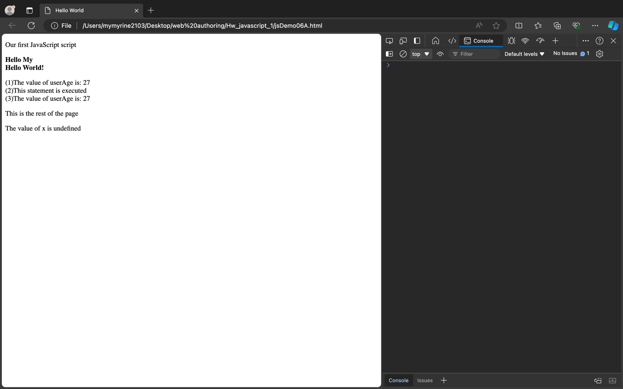
In the script with id s4, replace the declaration var x = 519 by var y = 519
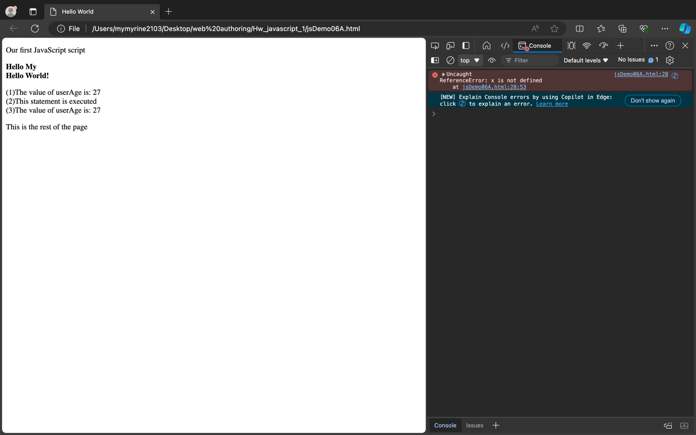
What do Exercises 1j and 1k tell you about the scope of variable declarations in JavaScript?
- Sometimes, the code just only be executed in that scope and cannot use it outside the scope.
What do Exercises 1j and 1k tell you about the way JavaScript code is executed?
- The code will run top down so should declare the variable before set the value for the statement.

2. Let us compare floating-point arithmetic in Java and JavaScript.
In the browser window you should now see the results of the various computations. Are all the results the same as for the Java program produced for input 4?
Java:
Input: 4
sqrt(4) = 2.0
4/2.0 = 2.0
round(2.0) = 2.0
2.0 > 0 : true
2.0 <= 0 : false
round(4.4) = 4
round(4.5) = 5
round(4.6) = 5
Javascript:
sqrt(4) = 2
4/2 = 2
round(2) = 2
2 > 0 : true
2 <= 0 : false
round(4.4) = 4
round(4.5) = 5
round(4.6) = 5
To repeat the computation for a different input, you need to refresh the page. Then a new prompt will appear. Enter -4 now and press return.
Compare the results produced by the JavaScript program with those of the Java Program for input -4.
Java:
Input: -4
sqrt(-4) = NaN
4/NaN = NaN
round(NaN) = 0.0
NaN > 0 : false
NaN <= 0 : false
round(-4.4) = -4
round(-4.5) = -4
round(-4.6) = -5
Javascript:
sqrt(-4) = NaN
4/NaN = NaN
round(NaN) = NaN
NaN > 0 : false
NaN <= 0 : false
round(-4.4) = -4
round(-4.5) = -4
round(-4.6) = -5

Finally, refresh the page again, enter 0, and press return.
Compare the results produced by the JavaScript program with those of the Java Program for input 0.
Java:
Input: 0
sqrt(0) = 0.0
4/0.0 = Infinity
round(Infinity) = 9.223372036854776E18
Infinity > 0 : true
Infinity <= 0 : false
round(0.0) = 0
round(0.0) = 0
round(0.0) = 0
Javascript:
sqrt(0) = 0
4/0 = Infinity
round(Infinity) = Infinity
Infinity > 0 : true
Infinity <= 0 : false
round(0) = 0
round(0) = 0
round(0) = 0
3. The precision of 64-bit floating-point numbers is necessarily limited. This problem is aggravated by the fact that the binary representation of these floating-points numbers allows to precisely represent a lot of binary fraction
what the floating-point numbers corresponding to 0.3, 0.2, 0.1 really are and what the results of 0.3−0.2 and 0.2−0.1 are:
- The decimal number 0.1 corresponds to the binary number 0.0001100110011001100110011001100110011001100110011 (and so on) in binary.
- Similarly, 0.2 in binary is 0.00110011001100110011001100110011001100110011001101 (and so on).
- And 0.3 in binary is 0.01001100110011001100110011001100110011001100110011 (and so on).
-> 0.1, 0.2, or 0.3 in your code, the actual stored value is a binary approximation of the decimal number,
- Due to these approximations, the results of 0.3 - 0.2 and 0.2 - 0.1 in JavaScript are not exactly 0.1. So in the result of the code:
(x == y) = false
(x == 0.1) = false
(y == 0.1) = true

